**Template for Activity on Gantt chart and Fishbone Diagram**

**Problem Statement for Activity:** Organizing a Sports event for University

**Team**

|  |  |  |  |
| --- | --- | --- | --- |
| Sr No | Roll No | Name | Role (Designer/Customer) |
| 1 | 11 | OM THANAGE | Customer |
| 2 | 12 | OMIK ACHARYA | Designer |
| 3 | 13 | OMKAR DINDE | Designer |
| 4 | 14 | OMKAR DESAI(Absent) | N.A. |
| 5 | 15 | OMKAR BHOIR | Customer |

**Tasks to be performed:**

To make Grantt chart and Fish-Bone diagram

**Team Member Allocation Table: Group 3**

**Gantt chart for task planning:** 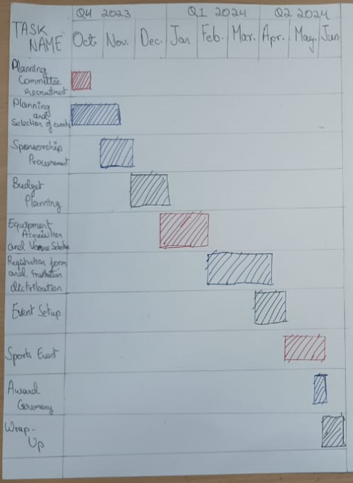

**Gantt chart for student involvement planning:**

**Fish-Bone diagram for the Activity:**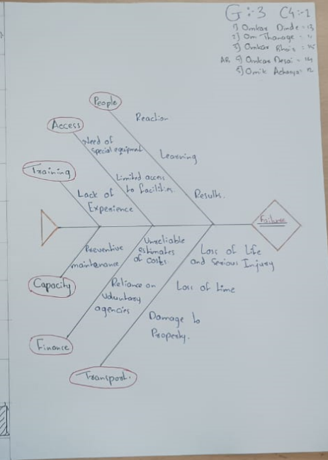

**Observations and Reflections:**

* Observations:-

1. From Grantt chart we got to know about how the things will work and the time required for it. Also, the Grantt chart should be made to evaluate the accuracy of the tasks and dependencies.
2. From Fish-bone diagram we got to examine all relevant causes and sub-causes for the event in question. It also helped us to identify the critical paths and the sequence of tasks that determines minimum duration required for the event.

* Reflections:-

1. By making Fish-bone diagram and Grantt chart we discovered efficiency in planning, areas for improvement.
2. Lessons learned included improved communication and risk mitigation strategies for future planning ventures.